Climate Justice & Governance Innovation Initiative Climate Law & Governance Day 2016
Concept Note

June 2016
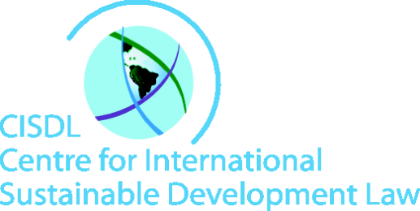
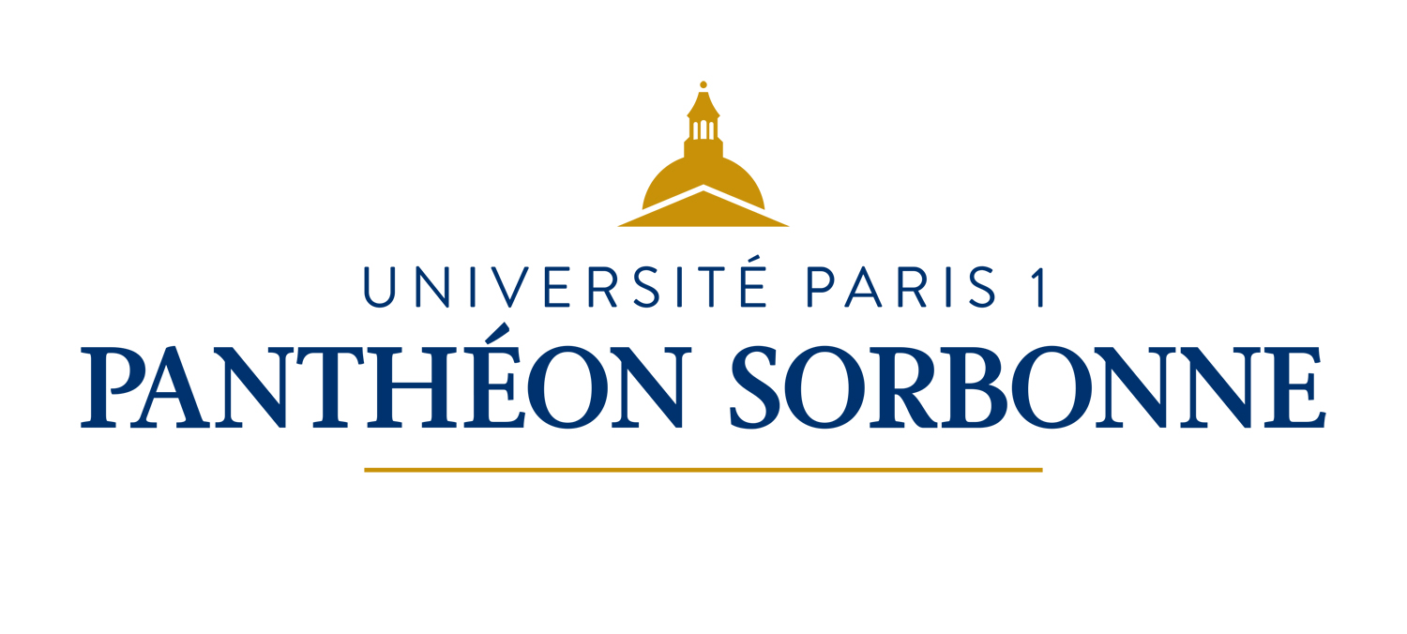
Cover Photo by Rosa Cabecinhas and Alcino Cunha, CC BY-SA 2.0. https://www.flickr.com/photos/rosino/84514010/

Climate Law and Governance Day 2016

Implementing The Paris Agreement

OVERVIEW
More than 30 islands have disappeared beneath the waves due to climate change associated sea level rise, underscoring the urgency for effective implementation of climate mitigation pledges. With 15% and 35% of global yield variation in wheat, oilseeds, and coarse grains dependent on one effect (El Niño), effective adaptation programs are crucial importance to avoid famine and hunger. In Southeast Asia, floods have affected more than 5.5 million people, causing €90 billion in direct economic losses and raising important questions about loss and damage. Such problems and impacts require urgent responses from all fields of human endeavor, including law.
In 2015, the Paris Agreement was negotiated by the Parties to the UNFCCC, and Sustainable Development Goal 13 was adopted to take bold action to combat climate change and its impacts. Strengthening climate law and governance will be crucial for successful implementation of the new Paris Agreement. Over 60 countries have announced plans to ratify the Paris Agreement in 2016, raising the possibility of rapid entry into force. The Paris Agreement and its Adoption Decision, explicitly recognizing the importance of climate justice in its preamble, provides for over 75 binding new obligations, many of which will be clarified as the ‘rulebook’ for the Paris Agreement is decided. Over 190 countries have already submitted their intended Nationally Determined Contributions, and over 150 of these commit to important policy, legal and institutional reforms. Law and governance innovation and capacity will be crucial on all levels, to ensure the world is prepared to implement effectively. Nearly 15,000 delegates are expected to gather for the UNFCCC CoP22 in Marrakech, Morocco from 7-18 November 2016, including many leading climate law and governance experts of the world. To explore pressing climate justice challenges, the second annual Climate Law and Governance Day (CLGD) is proposed on 11 November 2016 in Marrakesh, in parallel to COP22
Meetings with professors and experts from Morocco’s leading faculties of Law in Rabat, Settat and Marrakech, together with an Experts Roundtable during the 44th meeting of UNFCCC Subsidiary Bodies (SB44) in Bonn in May 2016, helped develop the agenda and scope partners. CLGD 2016 proposes to convene a community of international and national leaders and actors, including justice, environment, development and other government authorities, judges, law faculties and legal institutes, law associations, and others responsible for inspiring, innovating and building the capacity of the new generations of law-makers, working together to engage law and governance in global efforts to address climate change and implement the Paris Agreement.
The co-hosts, with due thanks to the Moroccan Presidency of the UNFCCC CoP22 and a network of academic and experts propose to invite Parties, UN bodies, intergovernmental organizations, academia, jurists and civil society together for Climate Law and Governance Day 2016 in Marrakech. Partners will be invited to contribute sponsorship funding and hosting to support the conference, and intervenors and hosts will be invited to submit papers and host sessions during the day-long event. This concept note outlines the proposed focus and proposal for CLGD 2016. A separate Call for Partners and Call for Papers and Intervenors will be annexed.

PROPOSED FOCUS OF CLIMATE LAW AND GOVERNANCE DAY 2016

Building on the success of the inaugural Climate Law and Governance Day at La Sorbonne Law School during COP21 in Paris on 4 December 2015, in collaboration with leading faculties of law of the Kingdom of Morocco, CLGD 2016 aims to convene government delegates, academics, practitioners, experts, and stakeholders from civil society and the private sector, to discuss the law and policy reform elements of Nationally Determined Contributions (NDCs) and the Paris Agreement, the Climate SDG, and the Doha Amendment to the Kyoto Protocol. The day-long event will take the form of an interactive dialogue with world-leading experts on international, national and local law and governance challenges in responding to climate change.

The dialogue and capacity building agenda for CLGD 2016 was discussed with expert professors and potential collaborations from Mohammed V Faculty of Legal Sciences in Rabat, Hassan I Law School in Settat, and Cadi Ayyad Law Faculty in Marrakech in April 2016, and with international experts and stakeholders in a roundtableon climate law and governance priorities for advancing the Paris agreement during the Bonn SB44 in May 2016. Proposed themes include:
- Climate Justice – human rights, access to information, public participation, and transparency,
- Climate Measures – investment incentives for mitigation, renewable energy and industries promotion instruments, sustainable landscapes, and carbon pricing,
- Climate Litigation – citizen suits and domestic courts roles in limiting climate change, and
- Climate Adaptation, Loss and Damage, and Migration – adaptation, the boundaries between adaptation and loss and damage, and migration and displacement related to the adverse impacts of climate change.

SUMMARY OF PROPOSAL

Marrakesh Climate Law and Governance Day 2016 will:

- Increase awareness of the international, national, and local law and governance mechanisms and challenges relating to global efforts to address climate change,
- Co-generate new law and governance knowledge and approaches by stimulating exchange between delegates, legal practitioners and legal academics on the contribution of law and governance to, and
- Strengthen capacity, collaboration and a law and governance community of practice to implement the Doha Amendment, the Paris Agreement, the Climate SDG, and the COP22 outcomes.

Activities leading up to and associated with Marrakesh Climate Law and Governance Day 2016 will include:

- A series of legal briefs are being prepared as background material for discussions on the current and potential role of international law and governance in mainstreaming biodiversity into national sectoral and cross-sectoral laws, regulations and administrative measures,
- A series of preparatory seminars and symposia in different law schools around the world, including across Morocco, McGill University, University of Cambridge, University of Nairobi and University of Chile, discussing legal and institutional reforms for implementation of the Paris Agreement.
- An international essay-writing competition and mooting competition, to engage law and politics students in discussions of how the Paris Agreement can be implemented on the ground in their countries.
- A half-day on-site workshop in the Blue Zone at COP22 on the contributions of international law and governance to addressing climate change.

The component elements of Marrakesh Climate Law and Governance Day 2016 will include:

- Keynote speakers and contributors from convenor organizations and partners,
- Briefings on the diverse contributions of organizations working on climate law and governance matters, and their plans for capacity building and dialogue related to implementing the Paris Agreement and NDCs, the Doha Amendment to the Kyoto Protocol, and the Climate SDG,
- Substantive roundtable sessions on key international, national, and local climate law trends and governance practices, how different legal instruments can assist in implementation, harmonising different areas of international law around the Paris Agreement, and mobilising interdisciplinary actors to build synergies for collaboration, and
- Identifying the future legal and governance research agenda, identify specific capacity needs, and opportunities for capacity building and technical cooperation.

A special international climate law and governance course is also proposed, to take place on Sunday, 13 November between Week 1 and Week 2 of the COP22 at Hassan 1 University Faculty of Law in the city of Settat near Marrakech, co-hosted with university partners and UNDP, among others. In this one-day course, for which a certificate shall be granted, international and leading national and regional scholars and practitioners will receive focused capacity-building and teaching, providing a model and partners for the launch of a new Climate Law & Governance Masters Degree with international support and partners, to be offered in the future by Hassan 1 University, as a legacy of COP22 that continues to benefit students and practitioners in the region for years after the events.

The outcomes of Marrakesh Climate Law and Governance Day 2016 will include:

- Online legal materials for teaching and practice, building on shared lessons learned, including legal working papers, case studies and good practice regulations, leading to the co-creation of new knowledge, and new opportunities to establish partnerships for research, technical assistance and capacity building to support international, national, and local implementation of the Paris Agreement,
- A forum for dialogue and summary report linking the results of Climate Law and Governance Day to the COP22 discussions, informing delegates of the results and outcomes, highlighting new opportunities cooperation to strengthen climate law and governance capacity, with resulting benefits for transparency and compliance;
- An informed and engaged climate justice community of practice, strengthened by the exchange of knowledge and legal experiences shared in Climate Law and Governance Day at UNFCCC COP22 in November in Marrakesh, Morocco, engaged in Climate Law Days at the Global Forum on Law, Justice and Development in December in Washington, USA and other fora, and supported by new capacity-building support such as a new Climate Law & Governance Masters Degree to be offered by international law partners, in collaboration with Hassane I University of Settat Faculty of Law (tbc).

HISTORY OF CLIMATE LAW & GOVERNANCE DAY

While the Climate Justice and Governance Innovation Initiative was formally founded in 2015 in wake of the Paris negotiation, its roots can be traced back to 2005 to Montreal, the UNFCCC CoP11, which was the first Meeting of the Parties for the Kyoto Protocol, when the CISDL at Faculty of Law, McGill University in Canada hosted a law and governance conference in the weekend between Weeks 1 and 2 of the COP. Since that time, a consortium of partners including UNDP and CISDL have organized side-events and workshops on climate law and governance during most CoPs. This history has included symposia / side-events on Strengthening Climate Cooperation, Compliance and Coherence (2005, CoP11 in Montreal), Sustainable Development Law on Climate Change: Emerging Legal Regimes & Mechanisms (2006, CoP12), Law & Governance of Climate Change Adaptation & Vulnerability (2007, CoP13 in Bali), Building the Low-Carbon Economy beyond Copenhagen: The Global Law & Policy Research Agenda & Climate Law and Governance Course (2009, CoP15 in Copenhagen). Further leading international events and experiences include Developing Sustainable and Equitable Legal Frameworks for the Global Low Carbon Economy (2010, CoP16 in Cancun), Legal Preparedness for Climate Compatible Development: Securing REDD+ (2011, CoP17 in Durban), Public Participation and Climate Governance (2012, CoP18 in Doha), Rights, Governance & Climate Change (2013, CoP19 in Warsaw), Innovations for Sustainable Energy: Smart Energy Path Planning, Law and Governance (2014, CoP20 in Lima) and Climate Law and Governance: Future Practices and Prospects (2015, CoP21 in Paris). The Initiative is initially focused on Climate Law and Governance Day in 2016 at the Marrakech CoP22 and activities in the MENA Region with UNDP, but may be expanded to other regions over time.

ABOUT THE MOROCCAN KNOWLEDGE PARTNERS

The dialogue and capacity building agenda for the overall Climate Justice & Governance Innovation Initiative and for CLGD 2016 and related events were discussed with expert professors and potential collaborations from Mohammed V Faculty of Legal Sciences in Rabat, Hassan I Law School in Settat, and Cadi Ayyad Law Faculty in Marrakech in April 2016. The ideas and proposals raised in those discussions have been enthusiastically supported by international experts and stakeholders in an international roundtable on climate law and governance priorities for advancing the Paris agreement during the Bonn SB44 in May 2016, and letters of partners have been extended to the Presidents and Deans of the three universities, proposing to collaborate. Hassan I Law School in Settat, Morocco has already confirmed as a principal partner of the Innovation Initiative, and a Moroccan co-host of Climate Law and Governance Day and related activities.

ABOUT THE CANADIAN KNOWLEDGE PARTNERS
The Centre for International Sustainable Development Law is a charitable international legal research centre with offices at the Faculty of Law, McGill University, in Montreal, Canada and subsidiaries in Cambridge, UK; Santiago, Chile; and Nairobi, Kenya. CISDL works to integrate environment, human rights and economy through leading international legal research and scholarship on international sustainable development law, and legal empowerment by organizing and contributing to courses, conferences, lectures, roundtables, seminars, symposia and workshops to promote new ideas, dialogue and collaboration on law for sustainable development. CISDL supports the increased understanding, development and implementation of law for sustainable development through capacity-building, capacity development and technical cooperation in all regions of the globe. The Monk School at the University of Toronto, the Law Faculty of the University of Victoria, and the Centre for International Governance Innovation with the University of Waterloo are close collaborators in the initiative. CISDL can be contacted through Ms Katherine Lofts, Programme Coordinator, at McGill University (klofts@cisdl.org) and through Dr Markus Gehring, Lead Counsel, at University of Cambridge (mgehring@cisdl.org).

