RBAS Calendar of Events
In order to add a new event to the Calendar of Events please provide us with the below details prior the event:

Event title: Launch of the Arab Network for Women in Elections and ArabEMBs Visitor Programme to the Tunisian Legislative Elections
Project/ Portfolio: Regional Electoral Support Project/ Elections MENA
Location (venue/ city/ Country): Movenpick Hotel, Tunis, Tunisia
Date (start and end date): October 4-7
Number of expected participants: 60-70
Brief description of the event (max 340 character): In an effort to increase women’s political and electoral participation in the Arab region, and to promote women’s role in elections as voters, candidates, party members, observers and election administrators, a regional network for women in elections has been established. The Organization of ArabEMBs, in partnership with the Tunisian Election Commission (ISIE), and with support from UNDP and International IDEA, are launching the Arab Network for Women in Elections in Tunis, Tunisia on October 5, 2019.
In light of the Network launch, the Organization of ArabEMBs will hold a meeting of the General Assembly to elect the first members of the Steering Committee of the Network and to discuss the latest achievements and updates of the Organization. The elected Steering Committee will then also hold its first meeting in Tunisia.
As the Network launch event coincides with the legislative elections in Tunisia, taking place on October 6, the participants will also take part of a four-day Visitor Programme, which consists of visits to the polling stations, results counting and operations rooms with a special focus on women’s participation in all stages of the electoral process, followed by a debriefing session on the next day, to share experiences, feedback and recommendations.
Overview and long description (share the concept note document or long description): CN attached.
Agenda (even if still tentative): attached.
Information about the participants profile (participants list/after the event starts): Participants are representatives from 13 election management bodies in the Arab world, representatives from regional CSOs and individuals holding leadership positions and working towards promoting women in politics. The launch is also attended by UN Women, and UNDP representatives including Sarah Poole, UNDP’s Deputy Assistant Administrator and Deputy Regional Director of the Regional Bureau for Arab States (RBAS).
Share the available documents (logistic note, concept note, Agenda Ar &Eng):
Contact details (focal point from the unit, job title, email, phone): Razan Masad, Regional Electoral Analyst, razan.masad@undp.org, +962798426472
Event cover image (any image representing the event. If not available, it can be the project logo or a picture taken on the first day of the event):
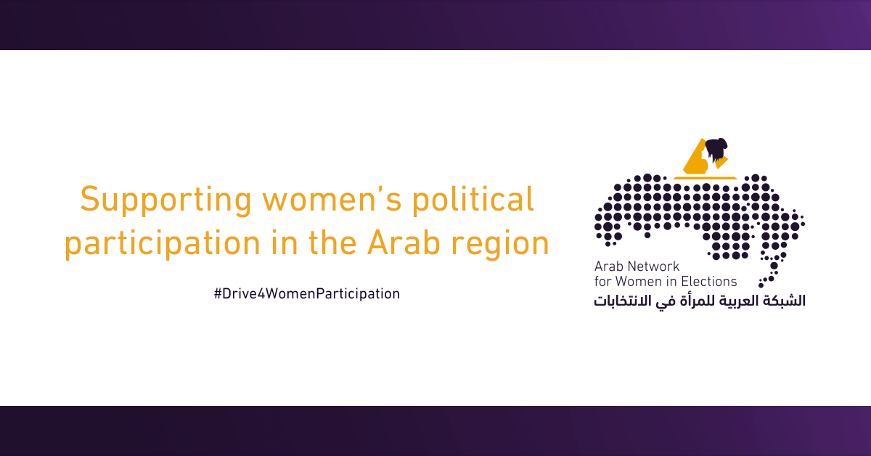
NOTE: kindly share all the available information and documents prior the event, and you may send any update (e.g. revised agenda, background documents, etc) at a later stage.

Send to:
Maya Beydoun: maya.beydoun@undp.org
Alessandra Muto: alessandra.muto@undp.org

